**Sociology Final Research Project**

1. Identify an appropriate Sociological topic that interests you.
2. Turn in project proposal form. You may work individually or in groups of up to 3. If you choose to work in a group and choose at a later date not to, you and your group members will be responsible for individual presentations. ***THIS IS NON-NEGOTIABLE.***
   * Due:___________________________________________________________
3. Complete background research of your topic and compose a bibliography of at least 5 sources, including one book. You must present a ***detailed background of your topic in your PowerPoint.***
   * Due:___________________________________________________________
4. You must apply one of the **three founding sociological perspectives** that we have learned in class to your topic. Your chosen perspective must be clearly woven throughout your research and presentation. Use **Table 1.1** included here as guidance.
5. Create an engaging, visually aesthetic and appropriate **10-15 minute PowerPoint presentation** for the class. ***You must include at least 1 relevant and appropriate video clip regarding your topic.*** No longer than 2 minutes.
   * Due:___________________________________________________________
6. Carry out a **5-10 minute class discussion complete with an article, handout or class activity** that actively engages the class and helps them to understand your topic. You are required to have at least 4 discussion questions prepared. You must make your own copies.
   * Due:__________________________________________________________

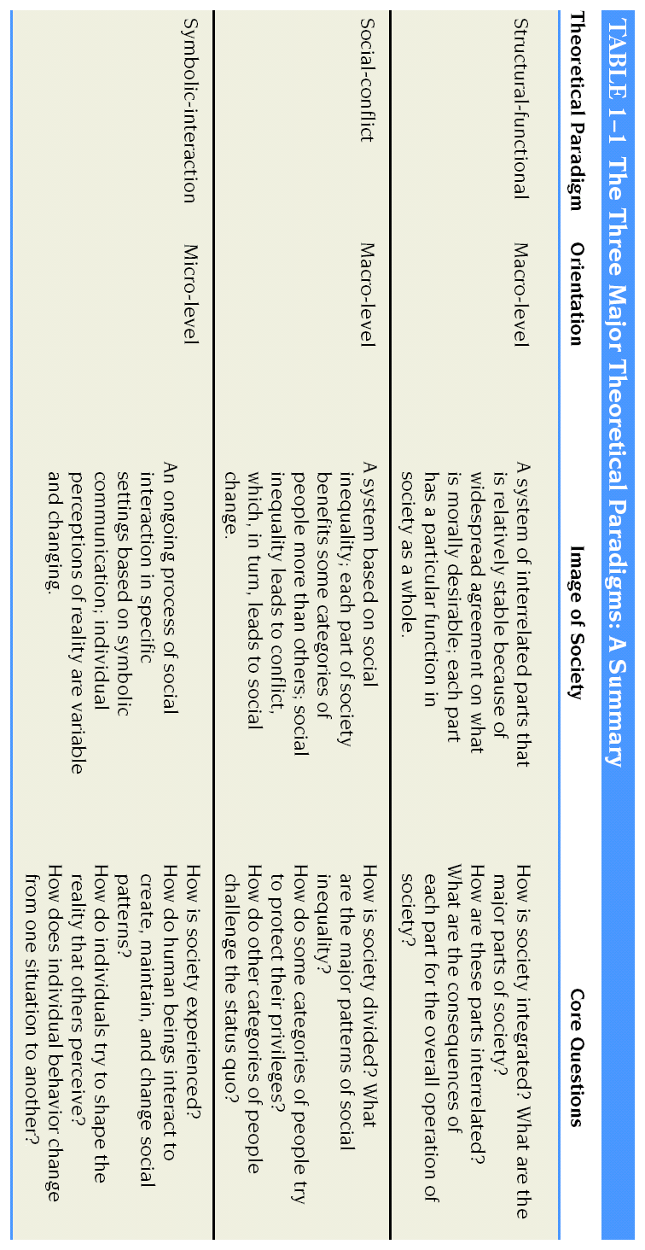

**Possible Topics (you are not limited to these)**

|  |  |
| --- | --- |
| * Subcultures   + Preps   + Surf Culture   + Greek Life (Frats & Sororities)   + Jersey Culture   + WASP’s   + Harry Potter-ans or Twilight-ers   + BodyBuilders * Cults * Stay at home dads * Racism * Family types * Religion in America * US Urban Problems * Inequality within public school systems/unequal funding of public schools * Teenage Pregnancies * Divorce and Remarriage | * Interracial couples: how they are treated by society * Consumerism * Female/Male body image; the media’s role * Prisons in America * Teen social networking/cliques/bullying * Social class and how it affects opportunity * Native American social problems * Children and Gender Socialization * Private vs. Public Schools (Education) * Cheating in American schools * Inequalities in Health and Health Care * Discrimination in workplace * Contemporary Gender Inequality * Agents of Socialization (Family, Mass Media, Peer Groups, School) |

Final Project Brainstorm

Sociology Ms. Dicks

NAME(S): _____________________________

**STEP 1:** Determine how and with whom you would like to work on this project.

If you are working with a partner, you only need 1 of these sheets.

**STEP 2:** Use your text book start paging through the index and chapters to see if there is any possibilities for a topic.

**STEP 3:** Using your book and the internet, please come up with possible topics and complete this preliminary brainstorming activity.

**Potential Topic 1**: ____________________________________________________

Why I/We Believe it is Relevant:

Possible Sources:

**Potential Topic 2:** ____________________________________________________

Why I/We Believe it is Relevant:

Possible Sources:

­­­ **Potential Topic 3:** ____________________________________________________

Why I/We Believe it is Relevant:

Possible Sources:

**Sociology Project Proposal**

**Name(s):**________________________________________________________

1. Identify your topic:_______________________________________________________________________
2. If you are working with a partner or group, list their names below:

1. _____________________________ 2.____________________________

**\*I understand that I am choosing to work in a group and if the group dissolves for any reason, *I* am responsible for an individual presentation.**

***Sign names here:_____________________________________________________________________________***

1. Explain how your topic relates to Sociology (if it is from the text book, provide page numbers).
2. From what sociological perspective (structural-functional, social-conflict, symbolic-interactionist) will you analyze this topic and how SPECIFICALLY will you do this?
3. Name and list 3 sources you have consulted.  How useful were they?
4. What sources do you ***plan*** to consult?  What specific information do you hope to get from these sources?

**Do not write below this line __________________________________________________________________________________________**

Accepted                                               _________

Accepted if changes are made           _________

Rejected                                                 _________

# Sociology Research Due Date: ___________

Topic: _____________________ Names: __________________________

|  |  |
| --- | --- |
| Sources: | How is this relevant?  What did you learn? |
|  |  |
|  |  |
|  |  |
|  |  |
|  |  |